Kagnew Station Reunion - San Antonio, Texas
September 15-18, 2016
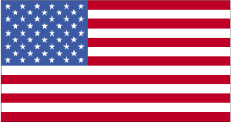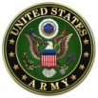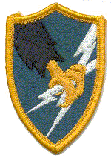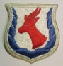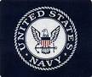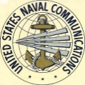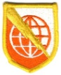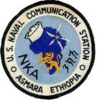
USA/ARMY/ASA/4th Operations Company and NAVY/USNC/Naval Communication Station – Asmara, Ethiopia
Hospitality room opens Thursday, Program/tours on Friday and Saturday, Banquet Saturday evening, self paced embarkation early Sunday. We hope this event will provide fun, fine food, refreshed friendships, and exciting speaker in this fantastic city.
The Kagnew Reunion Team has arranged accommodations at special rates ($99/night plus tax**) with the historic Indigo Hotel (Alamo location) and they are anxious to confirm your reservation at 1-877-846-3446 or 210 933 2000 before June 30, 2016.
Name(s) ________________________ Phone # ______________ Email - _______________________
Please indicate if you need hotel accommodations (Y/ N) and the date your reservation was placed (confirmed) ________
Please indicate your desire for specific items below:
Event Date # in Party Cost/person Total
Reunion 2016 Sept. 15-18 Vet only $40 _$40__
Alamo Tour & River walk Fri. 9/16 _______ $12 _______
Buckhorn Saloon Dinner Show Fri. 9/16 _______ $40 _______
Natural Bridge Wildlife trip * Sat. 9/17 _______ $50 _______
Banquet Featuring Dr. Don Wyman’s Presentation, “Codes and Ciphers of the Civil War”
- Texas Steak Sat. 9/17 _______ $40 ++ _______
Gourmet Chicken _______ $40++ _______
Please remit the total with this registration form at your earliest convenience…………………... $_________
Send total via check payable to: Ed Wheeler (1030 N. Ben Payne Road, Rockwall, Texas 75087)
*Group Transportation & limited menu Lunch included **Hotel Parking – $35.75 per day (off site options at discounts) ++ Tax & tip included
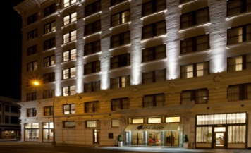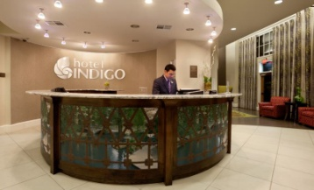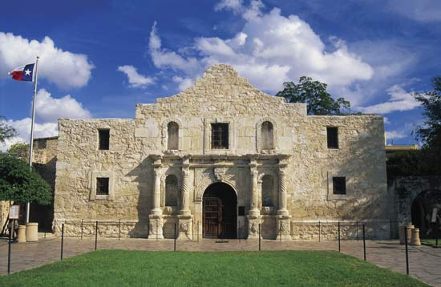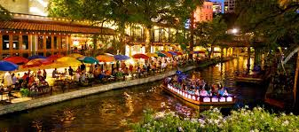

Alamo Tour, Friday 9/16, 9:30 am – 11:30 am $12
www.thealamo.org
Take short walk to meet in front of the Alamo (near audio booth) by 9:15 am
Battlefield Tour with guide 9:30 am - 10:30 am
Self Audio Tour 10:30 am – 11:30 am or as long as you like

Description: This guided tour follows the outline of the original fort and brings you to the North wall where Colonel Travis spent his final moments and where Davy Crockett defended the palisade. Following the guided tour, we will take a self-paced audio tour throughout
the Alamo, the Alamo grounds and surrounding area.
Note - A 1 ½ block foot path from the Alamo leads to the River walk for self paced
options: a trip on the river floats, lunch, shopping and/or sightseeing.

Buckhorn Saloon & Museum Dinner, Friday 9/16, 3:00 pm – 8:00pm $40
www.Buckhornmuseum.com

A short stroll from the Indigo Hotel will bring us to the historic Buckhorn Saloon & Museum. Visit the Museum at your own pace but be on time for the Texas Bar-B-Q dinner at 6:30 where Col. T.B. Reinhardt CPG, “Texas Bob” will bring Texas history to life.

Natural Bridge Wildlife Ranch Trip, Saturday 9/17, 9:00 am – 3:00 pm $50
www.wildliferanchtexas.com

Coach from Indigo Hotel (27 miles or about 45 minutes) 9:00 am – 10:00 am
First tour through park with animal specialist via bus 10:00 – 11:00 am
Lunch and walk-about (Limited Menu Lunch included in price) 11:00 am - 1:00 pm
Second tour through park w/o specialist via bus 1:00 – 2:00 pm
Return via coach to Indigo Hotel 2:00 – 3:00 pm
Description: African Safari – Texas style! We will take a leisurely coach ride through the 4 mile scenic ranchland for up-close experiences (no fences) among the 500 free roaming animals from exotic, native , and threatened species from five different continents.
The walk-about includes lemur island, kangaroos, parrots, and petting barnyard.

Featured Banquet Speaker: Dr. Don J. Wyman, Saturday 9/17, 6:30 - 8:00pm
www.donwymanpresents.com

Meet in the Indigo Hotel Maverick Room where this special Veteran of Army Intelligence will address ASA Army and Navy Vets with his presentation “Ciphers and Codes of the Civil War”. Dr. Donald Paul Wyman is a US Army veteran, and a retiree of 22 years with the Central Intelligence Agency. His “History of Intelligence” presentation at the request of the Director of the CIA was viewed by over 10,000 visitors to the Langley Headquarters. He is the author of “The Chosen Path: Based on the Life of Elizabeth Van Lew,” the Civil War Spymaster who is enshrined in the United States Military Intelligence Hall of Fame and has been rated as one of the “Best of all time.”

