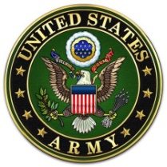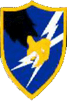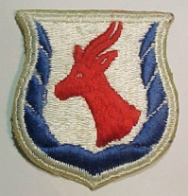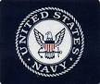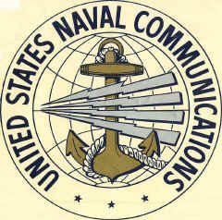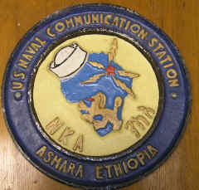
Kagnew 2016 Kickoff
Hello Fellow Kagnew Vets and Patriots!
The Kagnew2016 Reunion team is pleased to post the latest details for this special event. The December survey was less than definitive. So, Vilnis Pakains, Dave Mitchell, and I used our optimistic vision for the possibilities to arrange these details. We have worked hard to arrange a comfortable and exciting time at a reasonable cost for all our Army and Navy Kagnew friends in San Antonio, Texas in September. We trust that registrations will exceed our goals and confirm our optimism. We discovered another ASA group with reunion plans at the Crockett Hotel on this same weekend and it would seem “Texas Friendly” to invite their members to join in our events.
Reunion Publicity has been posted to the Kagnew Email List as well as several ASA/KAGNEW sites on Facebook , and I hope to get notices to several Newspapers before the Texas Summer arrives. I expect some of the dependents of Kagnew Vets will attend as well. We have already added dozens of names to the Kagnew Email list and I would request that each of you pass this information on to all that you feel would have an interest in this event. Check out VISITSANTONIO.COM for more information on San Antonio.
Current Hotel and tour attendance plans are modest but there is potential to adjust should advance registrations warrant but there is a time limit. The Indigo Hotel has less than 100 rooms and we reserved only twenty five rooms at the reduced rate. They will honor the rate on more rooms if available so let’s make our reservations early. Rooms will be in close arrangement with preference for a View of the Alamo and the Indigo Hotel will allow the first to call, the best choices of room type (Standard Single, Queen Double, or King). The Hotel Banquet Room capacity is approximately 100 and a backup facility will accommodate more than 250. I can only dream that so many Kagnew/ASA vets would attend this reunion.
Dave and Vilnis have obtained concessions on prices of these events and the Banquet Speaker has agreed to forgo the usual honorarium for his presentation. We did agree to reimburse reasonable travel expenses and three Kagnew Vets have already committed to underwrite about one third. Dr. Wyman will offer his books and other publications for sale.
Regrettably Vilnis’ Navy reunion is in a distant location and he will not be in attendance. Registration is a considerable task now and your KAGNEW REUNION TEAM will need some volunteers to assist with operations in September. Raise your hand if you might be able to help at that time and additional task details will be provided. Dave Mitchell and I will be happy to reply to any questions regarding these arrangements.
Please find the Registration form and event details attached. Let me know If you require a form in the mail.
Sincerely, Ed Wheeler Kagnew Ops ’ 1961-63

